**Week 4 Project: Analysis of Laboratory Results collected over a 9-year period**

Kaytie Moyer

Anderson College of Business and Computing

Regis University

MSDS 670: Data Visualization

John Koenig

September 14, 2021

**Summary**

The Week 4 Project showcases data taken from Exact Data Medical Health System laboratory results over a period of nine years, from 2005 to 2014. Medical data is important on multiple fronts. To providers and practitioners, it is a means of communication across differently oriented departments of medicine to help indicate a patient’s health. The patient is often seeking the information the tests can provide in order to answer concerns or fears over their physical health and status. The hospitals and care facilities use the information to determine where their most popular units are, and where resources should be allocated each fiscal year (Smith, 2008). This project analyzes the data from Exact Medical Heath System laboratories form 2005 to 2014 to answer the following questions; if the number of tests run by the health system has seen an incline or decline over nine years, which department runs the highest number of tests and if this seems to correlate with the number of providers in the department, and if there is a high positive or negative result rate to the tests completed. This will all be supporting evidence to answer the research question, “is the laboratory useful to the health system it is connected to?”

**Data**

The data was sourced from John Koenig’s MSDS 670: Data Visualization class, through the Course Resources. A link is provided in the references. All processes described and visuals created were done so through Microsoft Excel. The original copy of the data set included undefined variables such as member ID, test ID, test loinc, result loinc, numeric result, order number, and encounter ID. There were also multiple blank columns, abnormal value, reference range, and specimen. These were all removed, and additionally the columns provider organization and result status were also removed, as they held repeating data of no value to the analysis. Finally, test values were standardized into one of two categories: either Positive (requiring further testing or referrals to other departments), or Negative (requiring no further testing or referrals at that time). Tests were given a department category. These categories were organized as follows.

* Cardiology – tests focused on the heart and cardio system such as echocardiogram and ECG.
* Exams – physical or mental routine exams, physical pre-screenings to other laboratory work, and surface examination of oral, ocular, and auditory senses.
* Hematology and Immunology – blood and body fluid analysis, protein and lipid molecule profiles, and testing for specific molecule components (STI, pap smears, etc).
* Computed Tomography – mammograms, magnetic resonance imaging, X-Rays, and other computer based imagery or scanning.

***Analysis of Tests Completed by Date***

The test dates originally appeared in a YYYY-MM-DDTHH:MI:SS where YYYY is the year, MM is the month, DD is the day, T is the indication of the timestamp starting, HH references the hour in military time, MI is the minute, and SS is the second that the test results were completed and recorded. An example of this is 2005-10-07T16:15:00Z, the test being completed on October 7th 2005 at 16:15. This was changed to reflect only YYYY, or the year that each test was completed in order to summarize the nine years of data.

The results indicate that while the overall amount of completed tests have been increasing overall between 2005 and 2014, the only department to maintain a somewhat steady average is the Hematology and Immunology department. Computed Tomography experienced a sharp drop from 2005 to 2006 and showed little increase, Cardiology experienced a drop from 2005 to 2006 and also maintained little increase in numbers, and Exams increased from 2005 to 2007 before sharply dropping through 2008 and 2009 to stay at a low volume.

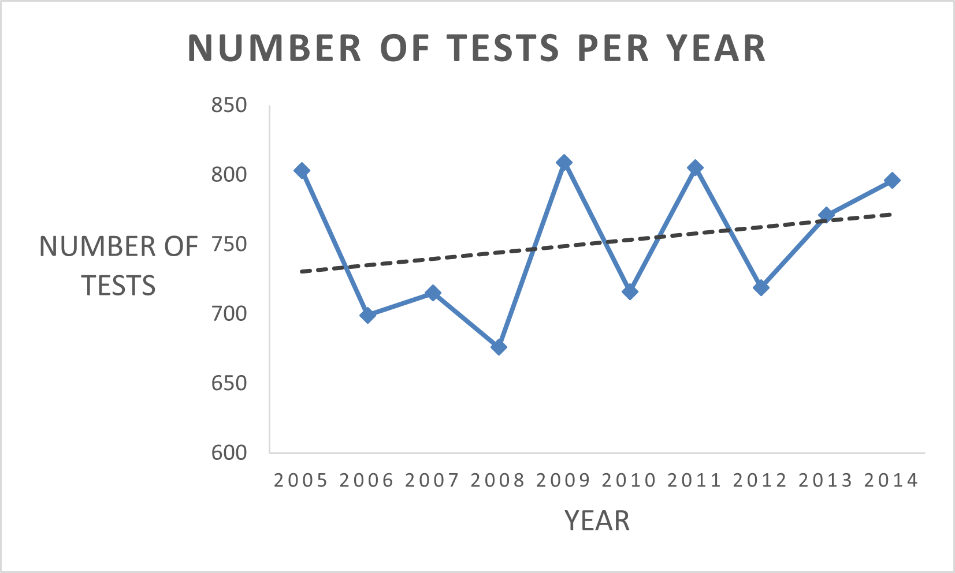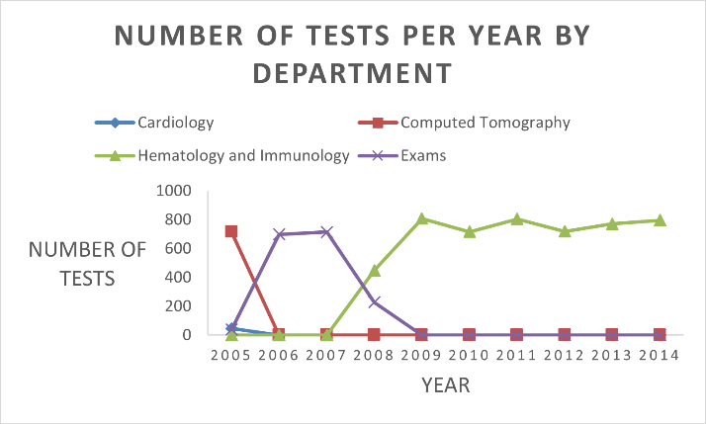

***Analysis of Tests by Department***

Each test completed was categorized into departments Cardiology, Computed Tomography, Exams, and Hematology and Immunology, dependent on the type of test completed. Tests completed between 2005 and 2014 were compiled into a total number for each department to determine which category of tests had the highest completion statistic.

The results illustrate that by far, Hematology and Immunology sees the highest number of tests. Exams were the second most visited department, with a little less than half of the results boasted by Hematology and Immunology. Cardiology ran the smallest number of tests at 51 total. To summarize, blood and body fluid analysis are the most common tests ordered and completed at the lab. It should be noted that these results cannot conclusively dictate productivity in any department, as each test requires different amounts of manpower, equipment, and time to complete.

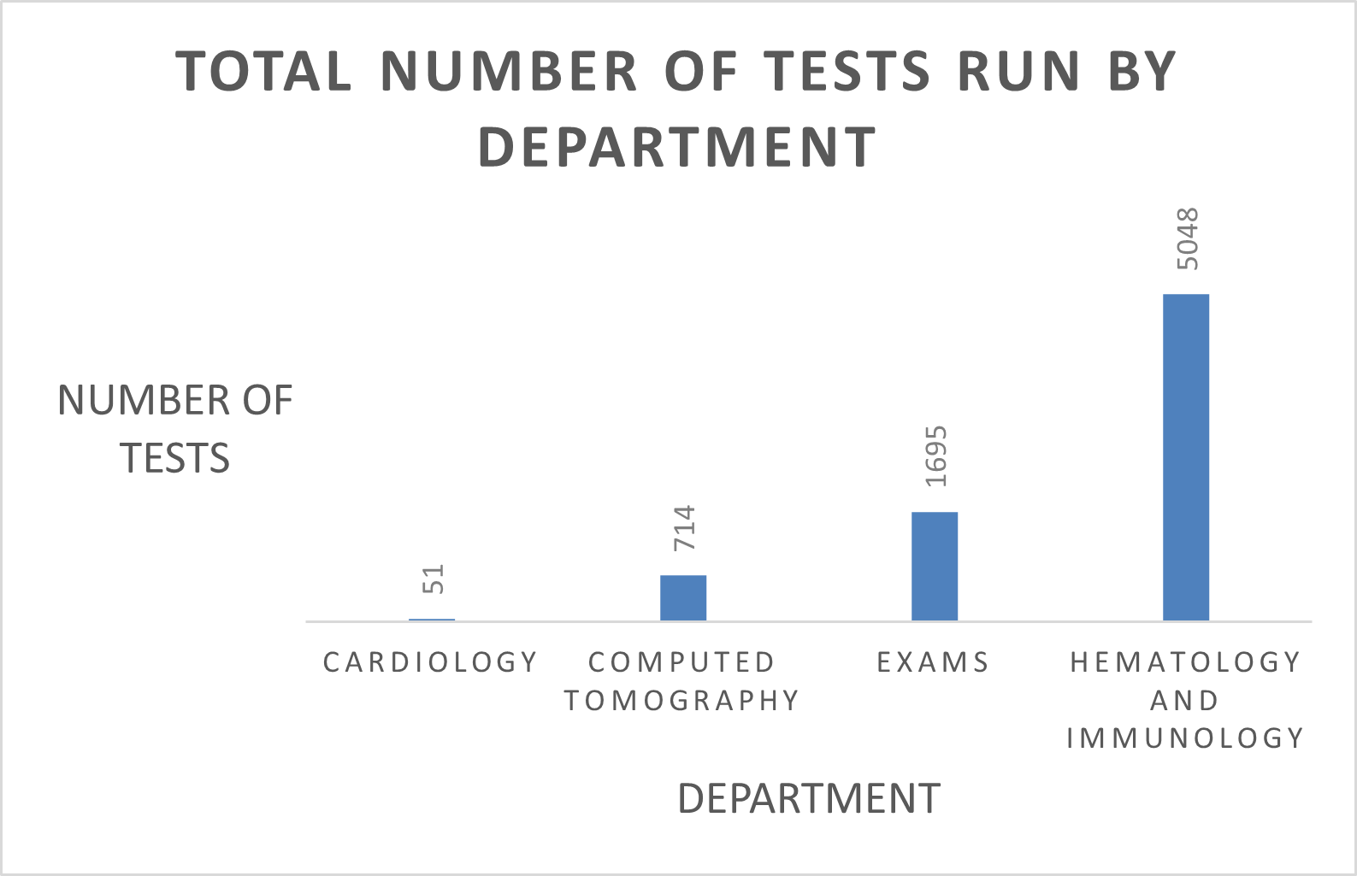

***Analysis of Providers***

Each provider employed by the Laboratory is assigned a provider number. The provider number is connected to each test the provider orders in order to track the productivity and activities of each provider the system contains. Each provider was assigned to a department in order to provide a quick analysis into whether the departments could be over-or-understaffed, when related to the tests completed by department. Some providers completed tests in multiple departments. In order to avoid over-stating data, each provider number was assigned to one department based upon the tests completed, and duplicates were ignored. For example, Cardiology recognized 25 provider numbers within the test completion tracking system. 22 of those provider numbers were only found in Cardiology, while 3 of the provider numbers were found in other departments and thus considered duplications.

Hematology and Immunology employs the highest number of providers, with Exams the second highest, Computed Tomography the third, and Cardiology the lowest employed department. This directly reflects the analysis of Tests by Department in the previous section.

According to these combined results, each provider in Hematology and Immunology completed about 75 tests on average, comparing to Cardiology, where each provider completed about 2 tests. Future analysis should focus on whether Hematology and Immunology should increase the size of their department based on resources required for each test and the length of time it takes to complete each test, in addition to employee satisfaction surveys and questionnaires.

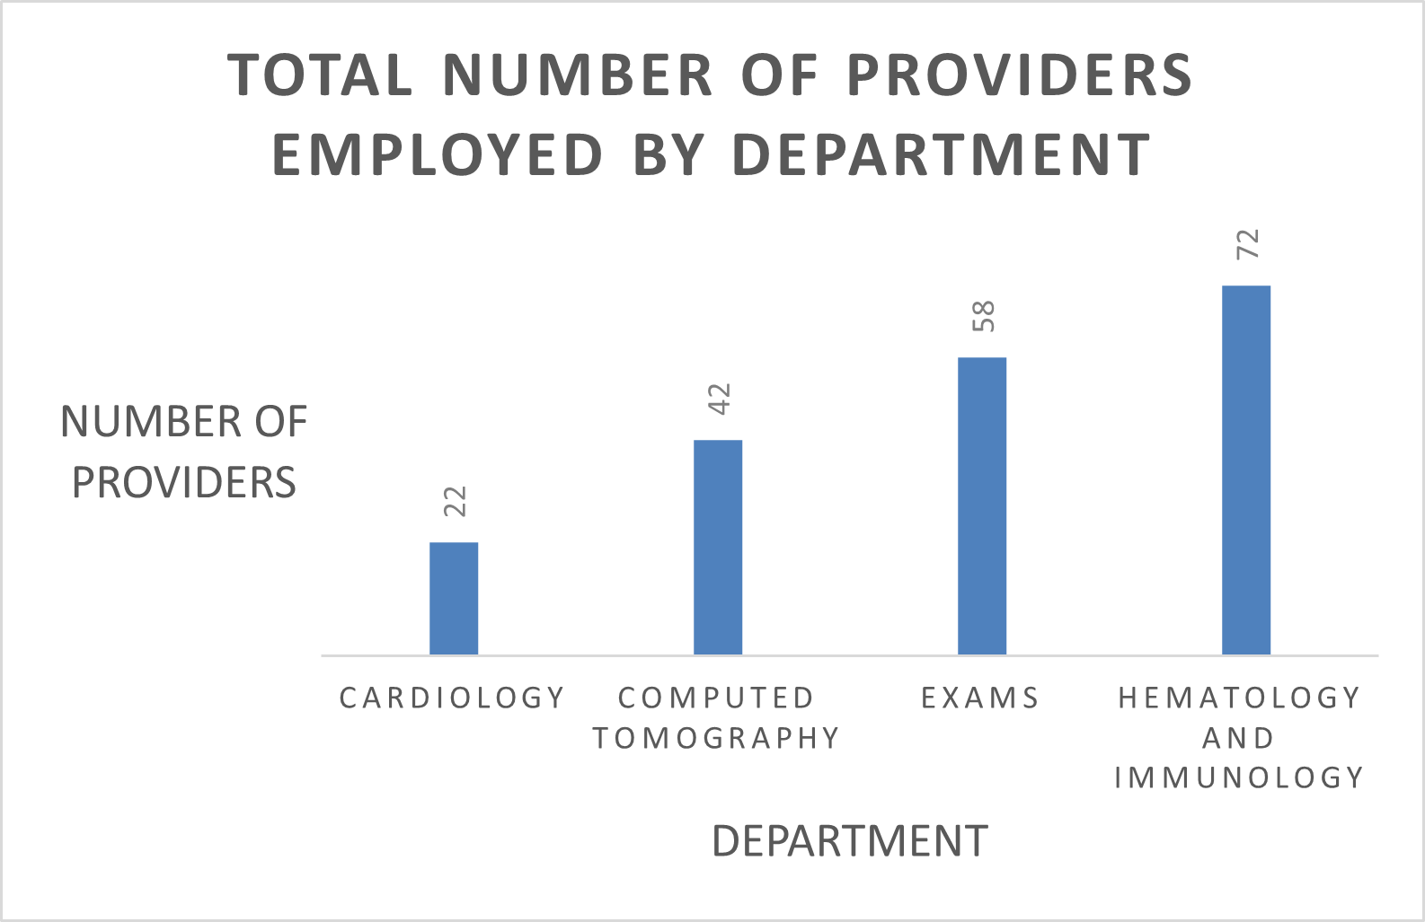

***Analysis of Test Results***

Test results were organized on whether they were negative (results were expected, no abnormalities found) or positive (results were not expected, abnormalities were found). The results were grouped by department to determine whether there is a high positive rate among one department in the lab.

The results pictured show that Hematology and Immunology, while also having the highest number of completed tests, also has the largest ratio of positive to negative results. Both the Exams and Cardiology department reported no cases of positive outcomes as a result of the completed tests. Computed Tomography reported 44 positive results against 570 negative results, while Hematology and Immunology reported 2166 positive results against 2882 negative results. Future analysis should work to determine if the higher positive ratio is a result of the higher number of tests or if blood and bodily fluid analysis have a higher chance of positive results because of the test completed.

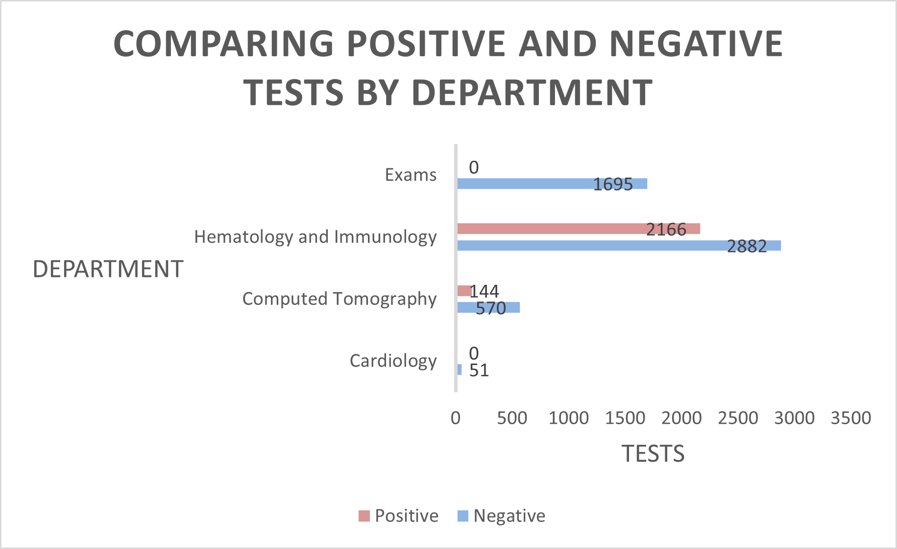

**Conclusion**

In conclusion, the lab experienced an overall slow increase in lab results, with the amounts varying each year between 2005 to 2014. The Hematology and Immunology department has seen increasing popularity in test completion from 2007 to 2014, while Cardiology has remained at a low number of tests, Computed Tomography sharply decreased after 2005, and Exams experienced a large decline after 2008. Hematology and Immunology ran the highest number of tests over the nine years of study, with Cardiology running the lowest number of tests. Hematology and Immunology also employs the largest number of providers, with each provider on average running 75 tests in their nine-year term. Finally, the positive and negative test result comparation determined that Hematology and Immunology held the closest ratio of positive to negative results, while two other departments reported no positive results at all within nine years.

With these results, it can be concluded that the laboratory is useful to the health care system it is connected to. Future research into the laboratory should analyze the positive to negative test result ratio found in the departments, and determine if this is a result of the test type completed. Surveys of employee satisfaction and workloads should also be done to determine if busier departments need to be increased in order to ease strain on employed providers. Finally, examinations of practices in departments with small numbers could be completed in order to determine if the results are a lack of needed tests, or a lack of equipment to provide the tests providers require.

References

Smith P. C. (2008). Resource allocation and purchasing in the health sector: the English experience. *Bulletin of the World Health Organization*, *86*(11), 884–888. <https://doi.org/10.2471/blt.07.049528>

<https://drive.google.com/drive/folders/15Rg3HhRjkT3zyMgT5WBTEtvRHpPL95a4> (the location of the data set.